**Newsletter**

**22nd November 2021**

**Sixth Form**

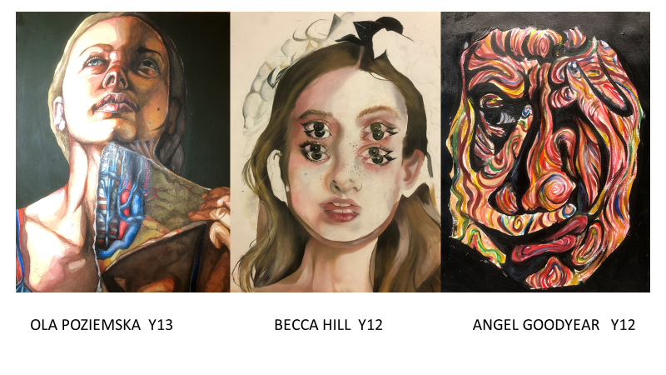**Year twelve and thirteen Art students are working with passion and dedication. See some excellent examples here showcasing their talents.**

**Year 11**

**Mia Gardner-Smith, Verity Thomas and Millie Shepherd** are achieving consistently high standards in Geography. Also a special mention to **Lewys Perkins** has had a focused and positive attitude in Geography this week.

The History trip to Conwy castle was a great success. The students were able to climb the turrets and walk the castle walls of a genuine 13th century medieval castle and empathise with the people for Edward the 1st whom they are studying in their weekly GCSE lessons.

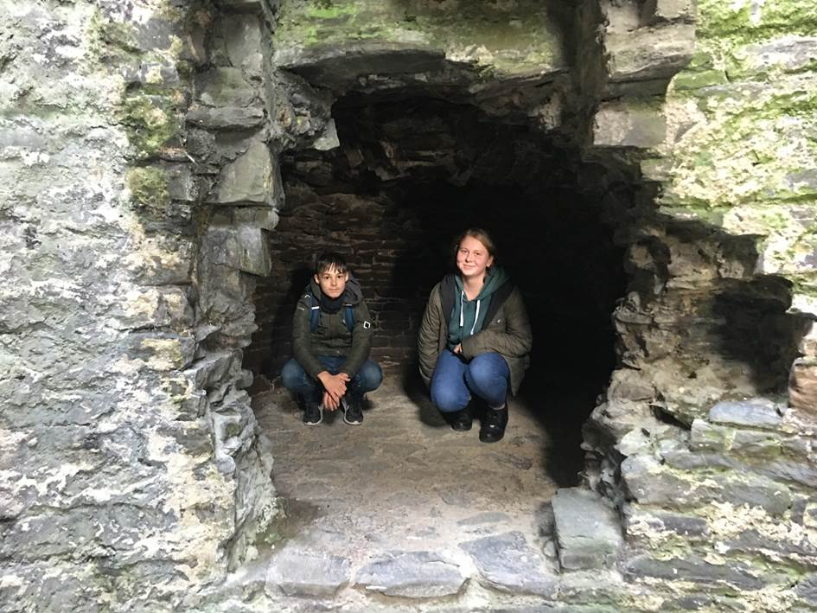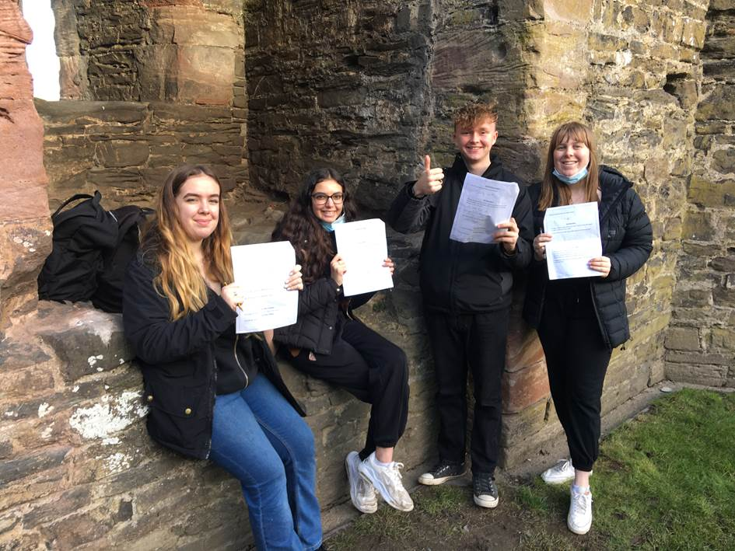

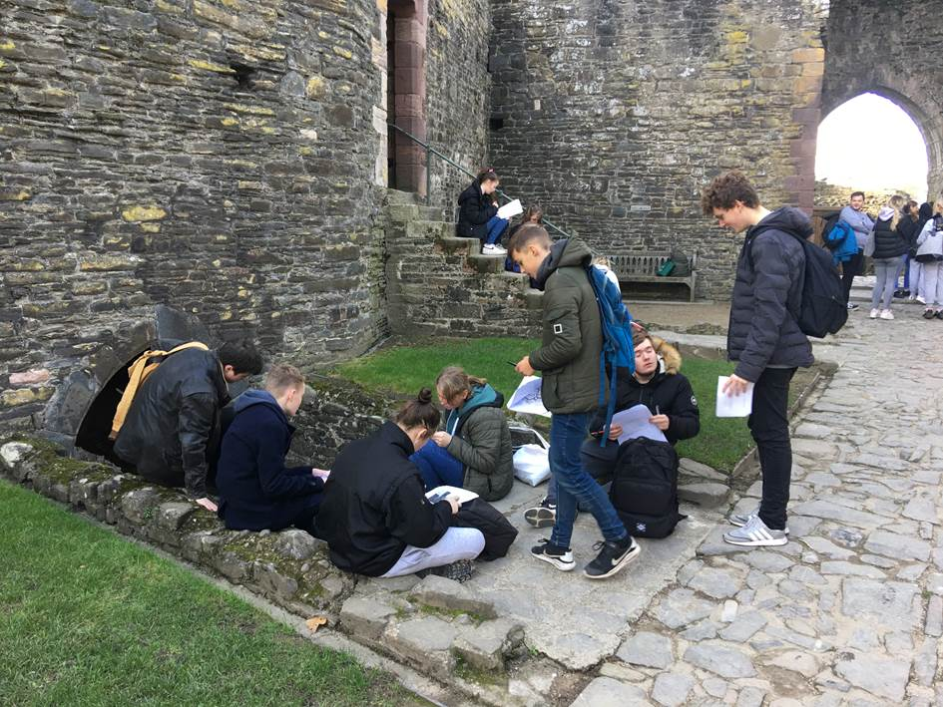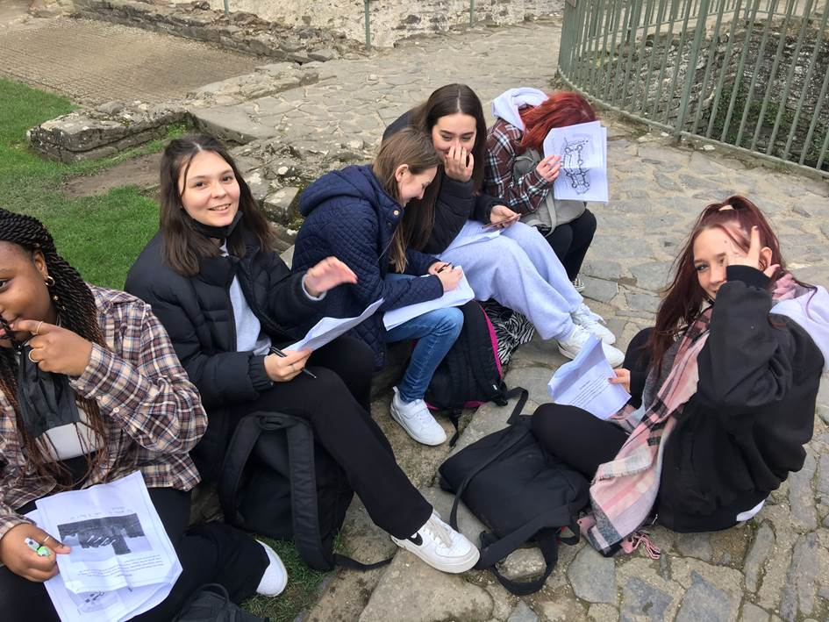

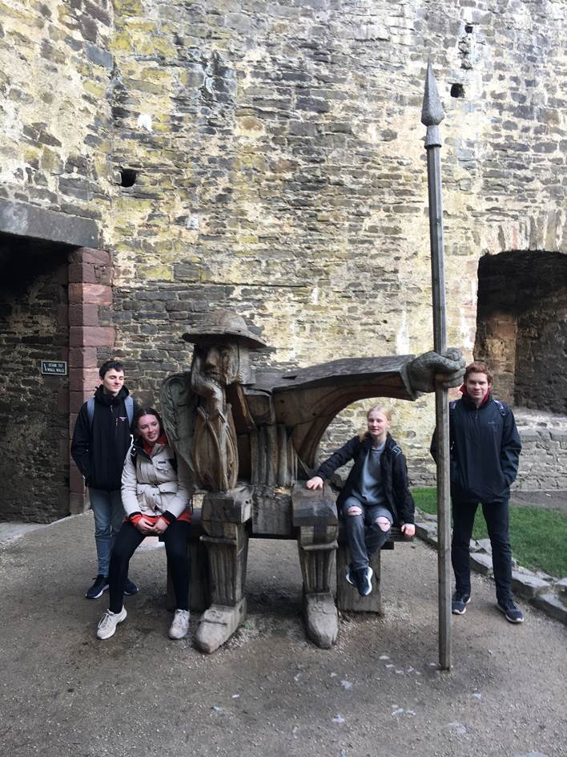

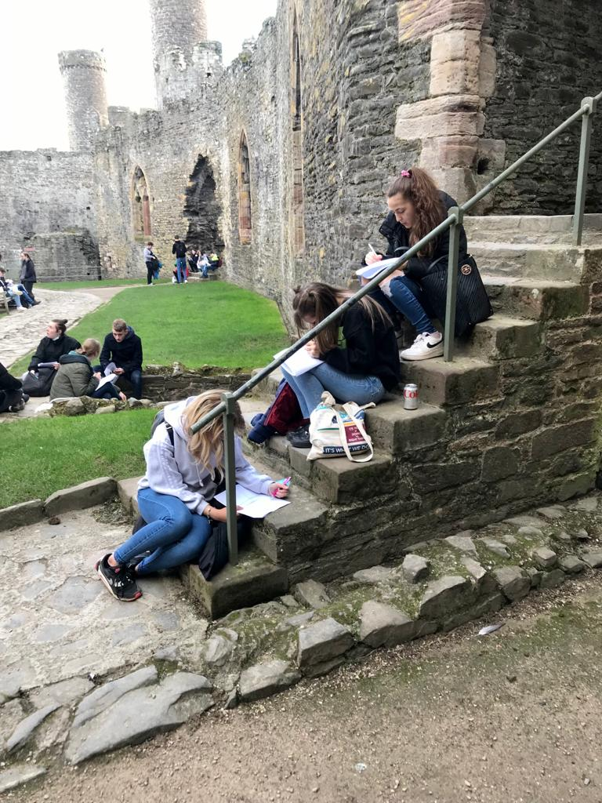

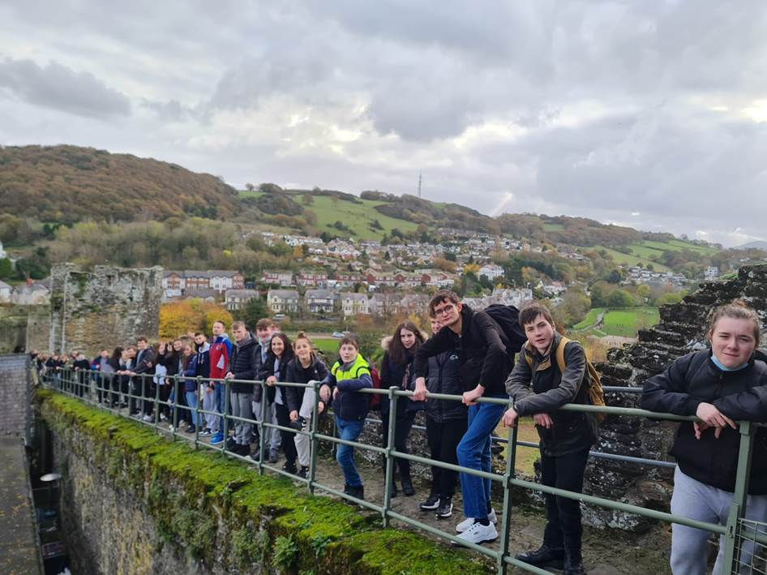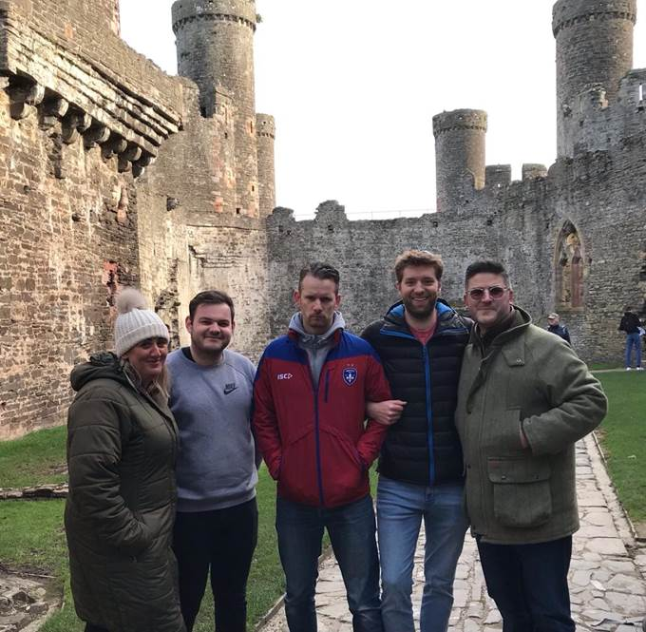

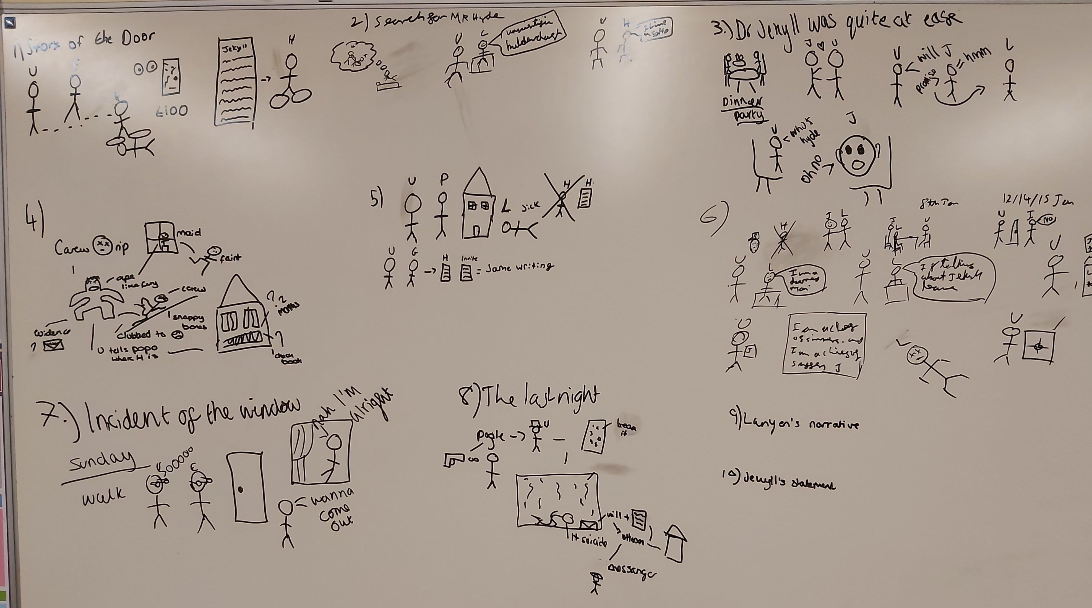In English **Emily Horton, Chris Kirby, Maha James, Sam Smith and Phoebe Davies** worked together to re-tell the story of Jekyll and Hyde) as a part of their CLIMB session. They created an image that is detailed and demonstrates their solid understanding of the key events.

Well done to all of 11A and 11B Child Development groups for their November assessment results! Mrs Wood was impressed that every student had made progress from their last assessment, and some excellent exam technique was shown.

**Maggie Winter, Amy Golden, Paige Rowe, Kelsie Read, Aimee Douglas, Grace Kasch, Daisy Jacobs, Poppy Robinson, Sophie Warner, Emily Shephard, Olivia Lewis, Lucy Oliver, Emily Pearce, Ambar Pitcher, Millie Rowe, Priya Sharma and Verity Thomas** all showed excellent subject knowledge.

**Mia Croft, Lilly Griffiths, Alicia-Mai Bradbury, Abi Eversham, Emily Eversham, Lilly Dawson and Ellie-May Preston** have all made good progress since their last assessment.

A special extra mention to **Lucy Oliver** who received a commendation point for her fantastic exam technique in the assessment. Mrs Wood was incredibly impressed by the level of detail in Lucy’s answers, and how well Lucy had followed the guidance in answering higher mark questions.

**In English Nicole Carswell** is commended for clear and effective reading of Lady Macbeth’s lines in Act 2 scene 2.

**Tom Quinn has impressed staff by his kindness, cooperation and resilience in Core PE.**

**Year 10**

**In History Sacha Hart, Sam Tranter and Cassius Loague** produced excellent guides to the Nazi leaders in Germany 1933.

**Nixie Pearson produced an excellent History assessment on the internal and external factors in Hitler’s rise to power**

**Barney Simpson, Sacha Hart, Immie Evans, Molly Parry and Jake Burton have been performing strongly in their GCSE History lessons this month and have impressed Mr Drew with their knowledge and understanding.**

10LMJ also made a brilliant effort and made three boxes of Christmas gifts, with special mention to **Summer Goodwin, Gracie Gould and Bryn Lambe** for their enthusiasm with this charity project.

In Geography **Lucy Davis** submitted a faultless 9 mark answer for Tyhoon Haiyan.

In Science **Jamie-Lea Tasker** exceeded his target grade in a recent science test.

**Bailey Hall, Alice McElroy, Ashton Hughes, and Jaxon Tandy** contributed to an insightful and mature discussion in PSHE this week.

**Sophia Birtles and Alice McElroy** have consistently impressed with their efforts in French this term.

10A Textiles have all been working hard in class and at home and have made an excellent job of exploring new textile techniques with a ‘Boho’ theme. See a selection of some of their sketchbook pages here.

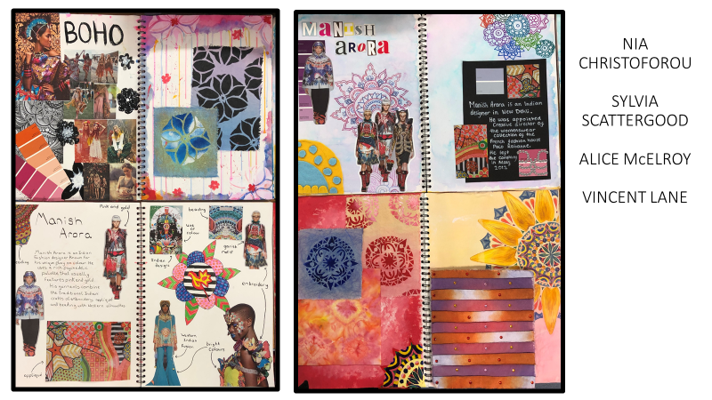

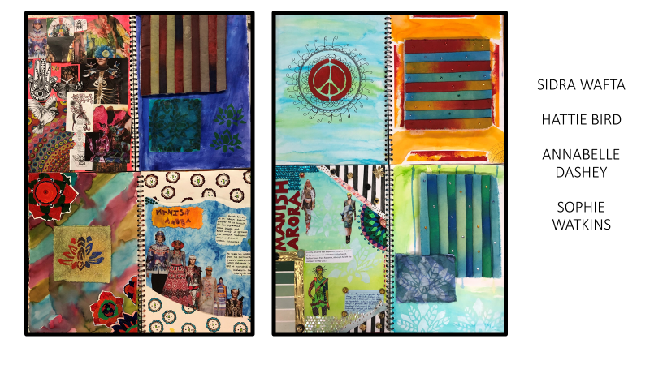

**Year 9**

**In French Max Rigby, Joshua-James Evans, Cerys Jones** have found out some good facts about Midi-Pyrenees this week.

9LA Maths group deserve a special mention for the focus, hard work and persistently great attitude towards their learning. They have been working on some challenging topics recently, including Pythagoras. In particular **Jamal Watfa, Brian Norris, Charlie Wright, Jake Johnson-Budd and Lucy Wood** have been made impressive progress.

**9R PE DR have shown for a positive attitude to learning in PE this week, playing conditioned badminton games.**

**9LD English for their work on Social and Historical Context about Of Mice and Men.**

Lexi Bennett, Kelsey Dewhurst Ford, Lillie Farrell, Emily Gandy, Ashton O’Keeffe, William Picken, Max Rigby, and Shaylah Stokes have consistently worked hard in their Philosophy & Religion lessons.

Year 9: In Science Faye Morgan for her being inquisitive in science, asking great questions to further understand new ideas. Daisy Moffatt for her tenacity for improvement after being unhappy with recent test results.

In History **Lewin Thomas Meredith, Matthew Oliver, Katie Maxted, Natasha Lindsay, Summer Griffin, Holly Dufty and Finley Jones** made an excellent start on their work on World War I by investigating the long-term causes.

**Year 8**

In History **Taylor Waldron**, Ted Kirton, Kaicey Robinson, George Clarke, Natalia Wierzchowska, Theo Burrows, Daisy Morgan, Isabelle Cooper and Fin Garlick have demonstrated excellent knowledge in their enquiry into Mary the 1st.

In History **Charlie Tranter,** Amy Ross, Blake Clarke, Erin Baker, Zac Thomas, Viya Patel, Charlie Drinkwater and Florence Bird worked really hard on their ‘how to be happy’ posters in their PSHE lesson this week.

Freya Austin, Finley Checketts, Amber Goodyear, Rosey Eckley-Williams, Owen Fletcher, Archie Hirschfield, Felicity Jordan, and Leo Leverett-Hawes are commended for their work in Philosophy & Religion this week.

Year 8 Tutor Time: Drew Hankins and Millie Lang for showing great kindness in preparing their own shoebox gifts for charity (and filling their shoeboxes!).

**Jamie McCammon (8RD) for great work in Computer Science & Media, helping other students.**

**8R PE DWCA M2 for their efforts in football (in PE) this week, developing their dribbling and shooting skills.**

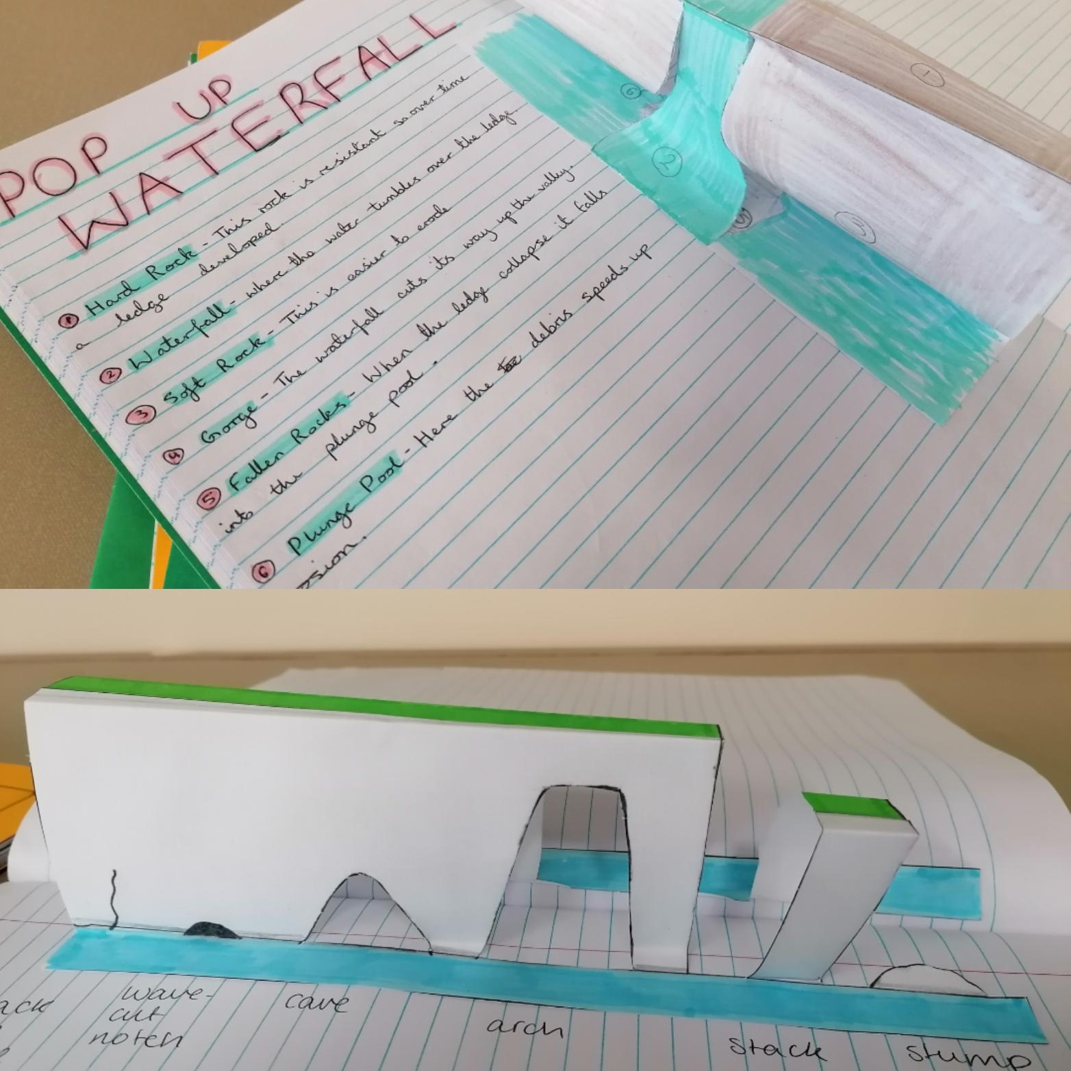

Mrs Stace's KS3 classes have been creative this week. Year 8 have produced marvellous Pop up Waterfalls and Year 9 a model of Landforms of Erosion.

**8R PE DWCA M2 for their efforts in football (in PE) this week, developing their dribbling and shooting skills.**

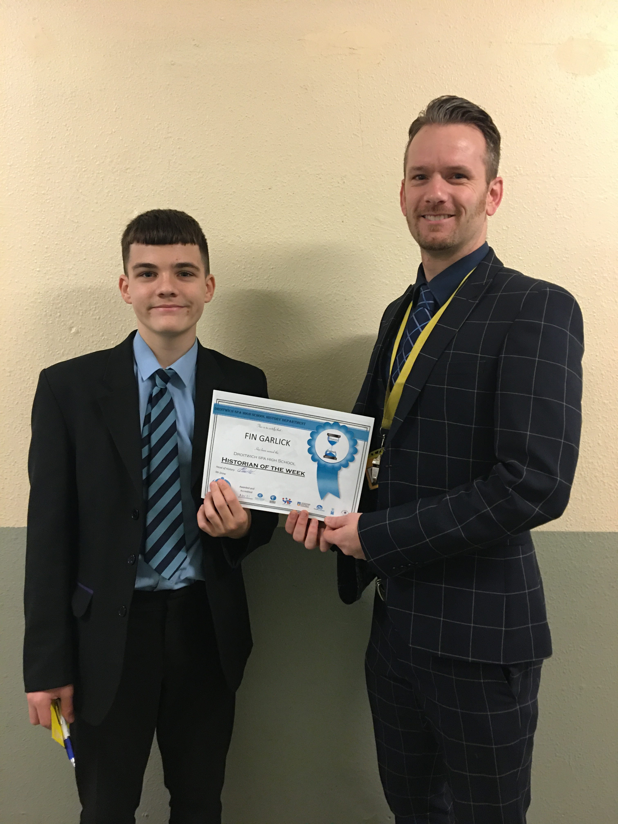

**Fin Garlick in year 8 was Historian of the week**

**Isabelle Butcher, Jack Crowther, Rebecca Johnson, Arthur Wilkinson and Carter Webb produced a superb role play on Mary Tudor and her suitors in year 8 History**

**Paige Shaw produced an excellent Network diagram on the key characters in Henry VIIIs divorce and reformation of the English Church.**

**Good News from the Design & Technology Department**

It’s been a busy term in the D&T department since September. We have had many “stars of the week” but have been celebrating them on our Instagram account: <https://www.instagram.com/dshs_design/> There are almost 50 posts made up of 140 images and videos that showcase the work of 80 students from Year 8 to Year 13. However we realise that not everyone wishes to be on Instagram so here is a quick round up of the names of the students that have had their work included so far.

**Year 8 -** Excellent design sketching skills: **Harry Smart, Aleisha Layton, Erin Nicklin, Viya Patel, Lily Smith, Erin Kilmartin, Kadi-Monique De La Guerre, Sophie Parkinson, Zac Thomas, Florence Bird, Bethan Evans, Erin Baker, Lola Winnall, Isabelle Shewell, Jamie McCammon, Ania Waldman, Eva McKay, Justin Honey, Leticija Grunte, Mary Jane Peace, Drew Hankin, Paige Shaw, Pippa Lang, Emily Warne, Charlotte Jennings, Fern Callow, Amelia Lloyd-Rogers, Abigail Plant, Isabelle Cooper, Libby Goode, Theo Goodman, Matthew Howard, Olivia Knight**

**Year 9 -** Impressive final products in the bling ring project: **Harry Guest, Callum Childs, Amelia Chagall, Logan Pugh, Nicola Pawlak, Skye Wilson, Lillie-Rose Willets, Owen Exon, Ella Marshall, Chloe Randle, Alfie Drinkwater, Liam Duncalf, Vinnie Paxton, Rory Crawford, Daisy Tibble, Natasha Lindsay, Arlyia Hussey and Vethesh Thivakaran**

Excellent designing progress in the “Animal Fold It” project: **Jess Jelfs, Jessica Evans, Leah Harrison, Ruby Lines, Will Broughton, Tom Rogers, Will Howard, Rory Crawford, Daisy Tibble, Vinnie Paxton, Arlyia Hussey, Jack Daniels and Natasha Lindsay**

Cool pop-up card designs: **Owen Exon, Daisy Evans, Lacey Groves, Jaygo Morris, Nicola Pawlak, Hannah Allen, Kiera Yates, Skye Wilson and Grace Winter**

Owen Exon has produced an amazing 3D Printed Chess Set.

**Year 11 Engineering -** Ingenious mechanical devices by **Frankie Walker, Olivia Gregory and Matt Hatfield**

**Year 12 -** Wonderful design sketching by **Tia Davies, Dan Court, Oliver Broomfield, Fin Bird, Will Atherton and Lottie Mountford.** There will be more added in the next few weeks. The Year 12 Product Design have all made a really positive start this year.

**Year 13 -** Innovative laser cut products by Ben Wood, Ben James and Nathan Law.

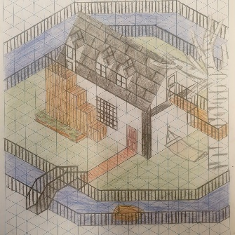 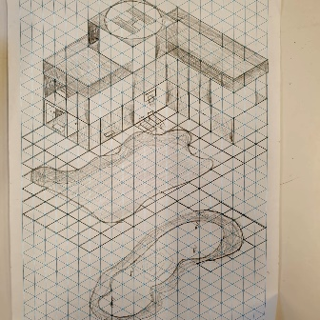 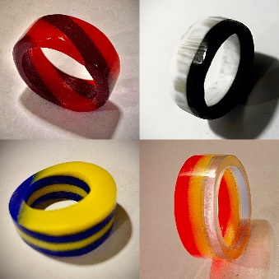

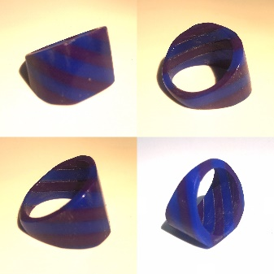 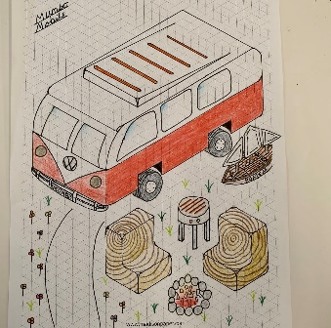 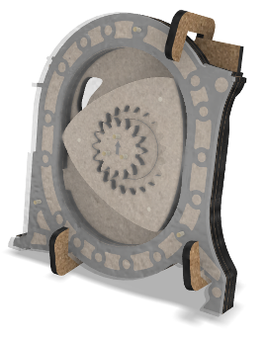

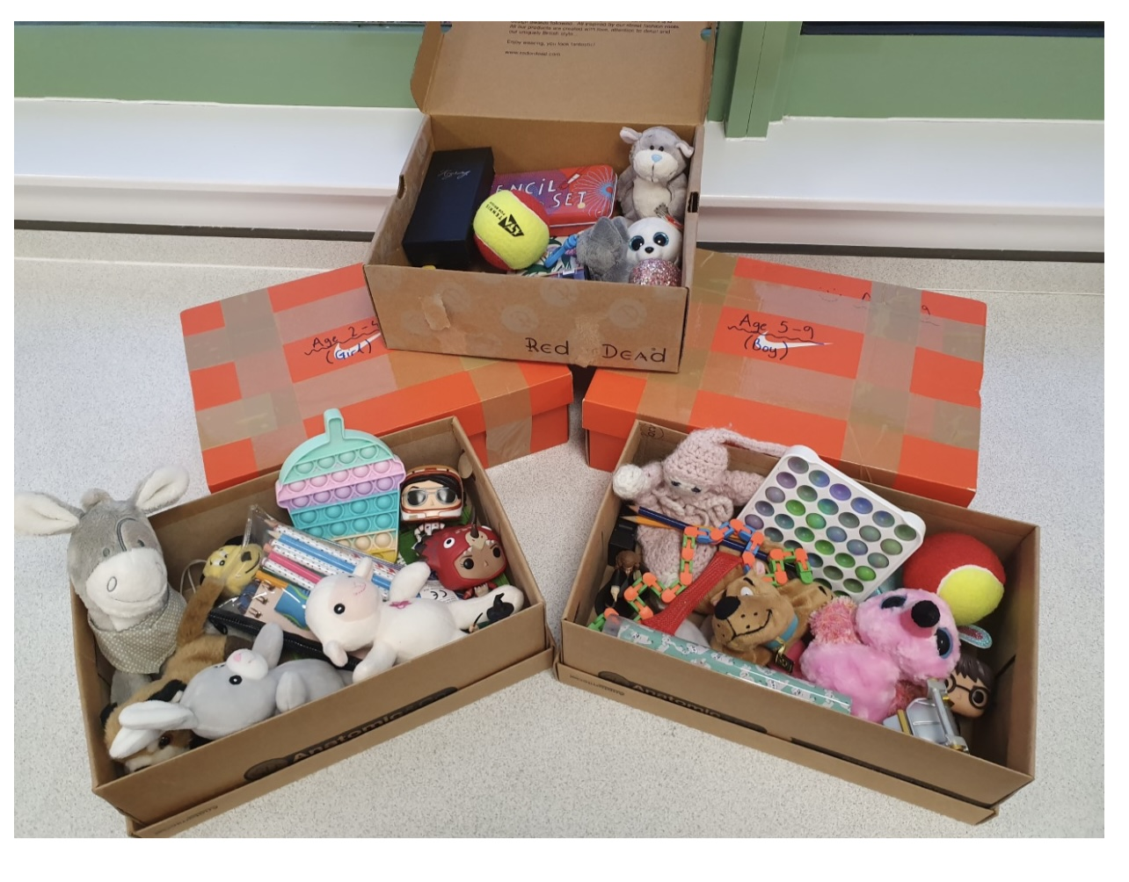**I wanted to put Mr Snell’s tutor group in Stars of the Week for their efforts with the Samaritans’ Christmas Gift project, they filled five full boxes (pictured below) with toys and gifts for children in developing countries, I was really impressed.**