Droitwich Spa High School Lesson Planner

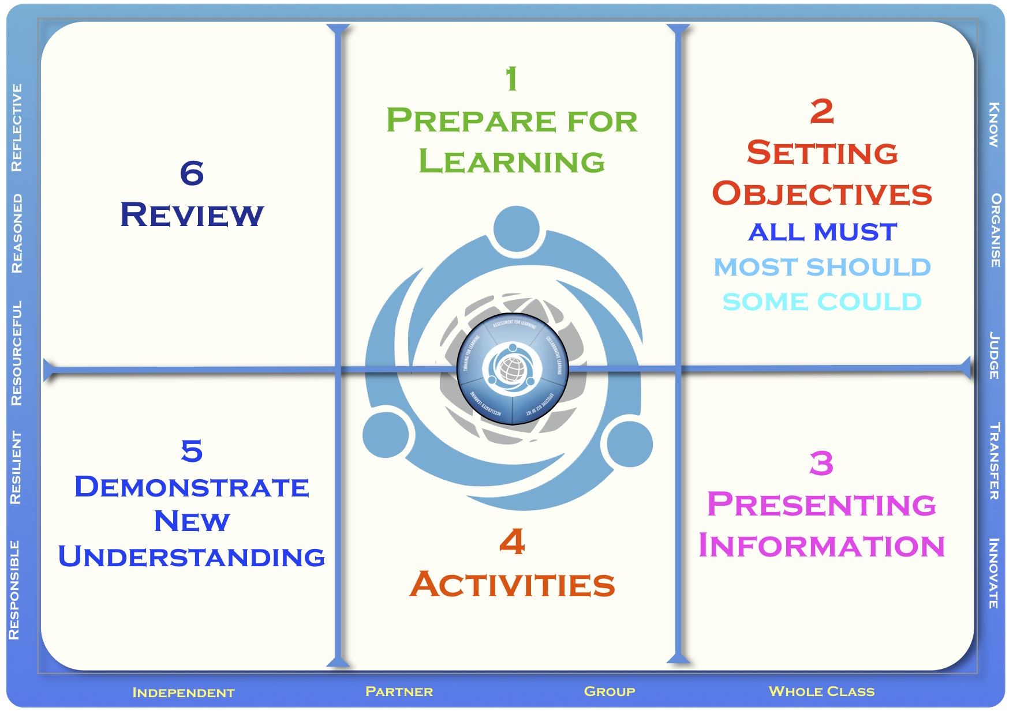

Teacher |  | Topic | KS3 Animal Biology
Date |  | Group
Subject |  | Context | This lesson is half way through a series of 14 lessons looking at system, nutrition and respiration. Pupisl are required to prepare a presentation in conjunction with work done in our partner school in India.

SEN Information | This section may not be needed and can be deleted if you can
Gifted and Talented | provide a detailed pen portrait of the class which allows the
Other student info | observer to see SEN, G&T and other relevant information

Lesson Plan
Prepare for Learning | The previous lesson was looking at the effects of exercise on our body. Here pupils will build on that and look at energy requirements and nutrition. Homework form previous lesson was to keep a cart or record of what you eat for 24 hrs.
Setting Objectives | LO: What does it mean to have a balanced diet?  Outcomes:  (All) Name the 7 components of a healthy diet  (most) Describe what makes up a balanced diet & give an example  (some) Offer advice to patients on their dietary needs
Presenting Information | The healthy eating plate will be used to present information to pupils about current British gov advice on eating well.
Activities | Hook: play a clip of a sporting event, something stimulating and ask how does a person get to be so fit & healthy? Discuss ideas of training and genes eventually diet will be raised.  Starter: Ask pupils name the 7 components of a healthy diet in their book.  Task 1. Using food labels pupils try to find 2 or 3 examples of each component. Class discussion of ideas/findings. They can use their HWK to add to this table.  Task 2. Use the healthyeatingplate.gov.uk pupils describe what makes up a balanced diet. Pupils use the plate to design a menu for 24 hrs that they would recommend to a friend. Present ideas.  Task 3. Pupils use patient cards to offer dietary advice to the 4 patients.  Task 4. Present ideas to class | Ongoing Review  Outline in these sections the way you will monitor and adjust the lesson dependent on the progress being made by each group of students.
Demonstrate New Understanding | Students will demonstrate recognize key components to a balanced diet and describe what should be in a balanced diet. Some will be able to identify diets that are not healthy and make recommendations as to how to improve them. | Ongoing Review
Review | Students will present their dietary advice to the class for each or one of the patients. Advice should focus on suggestions to improve current diet of patient.

