Droitwich Spa High School Lesson Planner

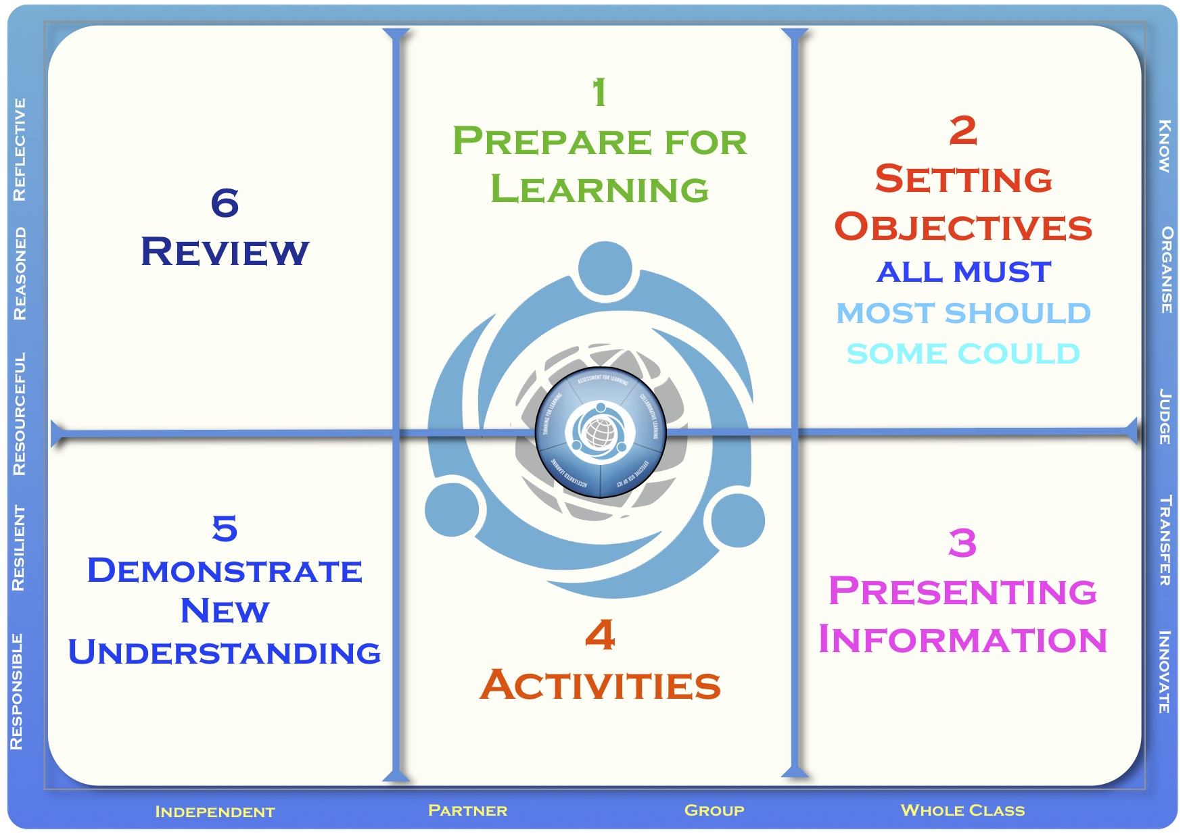

Teacher |  | Topic
Date |  | Group
Subject |  | Context | Lesson 2 of a dual lesson on Nutrition and energy. Previously students have looked at what makes a healthy balanced diet.

SEN Information | This section may not be needed and can be deleted if you can
Gifted and Talented | provide a detailed pen portrait of the class which allows the
Other student info | observer to see SEN, G&T and other relevant information

Lesson Plan
Prepare for Learning | Last lesson pupils discussed a balanced diet and suggested dietary advice to patients based on current Gov advice.
Setting Objectives | LO: How much energy do I get form my food?  Outcomes:  (ALL) Recognize that different groups of people have different energy demands  (Most) Interpret data on energy  (Some) Design their own lunch bar targeted at a group of people based on their energy needs
Presenting Information | What is the new information and how will it be conveyed?  What are you teaching/ what are the students learning?  Are you using technologies to illustrate/demonstrate/explain?
Activities | Hook: Teacher runs laps of the classroom whilst pupils are entering etc. Acting very energetically!  Starter: What do we use energy for? Ask pupils to match data to activity level.  Task1 Pupils’ produce bar chart of energy requirements (optional)  Task 2: pupils design their own lunch bar to be targeted at one of the key groups of individuals discussed in the starter activity. | Ongoing Review  Outline in these sections the way you will monitor and adjust the lesson dependent on the progress being made by each group of students.
Demonstrate New Understanding | Pupils will present work on the Lunch bar to the rest of the class and demonstrate the ability to link ideas of energy demands and nutrition | Ongoing Review
Review

