Name of Game: Team Aim

Equipment Required: Balls, Markers & Beanbags

Age Range: Infant / Junior

Maximum Numbers: No Limit

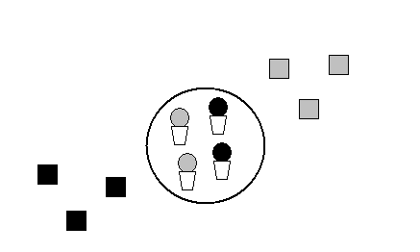

Children are arranged in teams of a certain colour.

Each team has beanbags of the same colour and they take it in turns to throw to knock the same coloured ball out of an upturned marker.

Winning team is the first to knock all their balls out of the circle.

