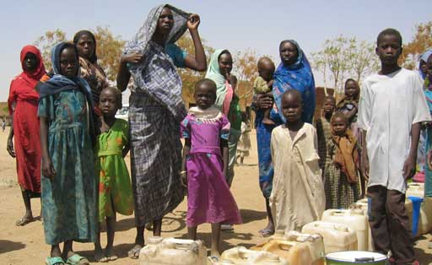
How would you feel if you were there??
The ground is very dry and looks dusty. I can see this from people’s shoes being dusty.

